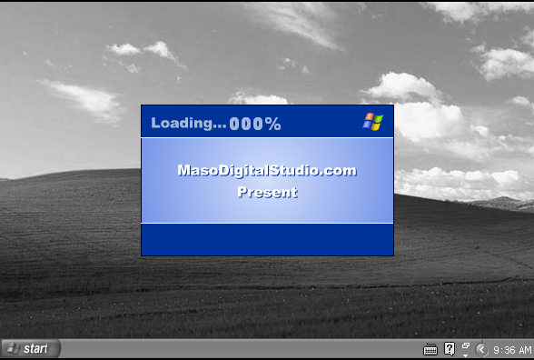

WHAT HAPPENS TO YOUR COMPUTER WHEN YOUR NOT THERE

